Sept. 23. 2025
Welcome Day:
Exodus 14:14
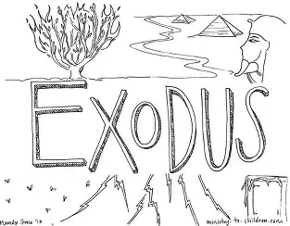

Sept. 30. 2025
Lesson #1: Moses Is Born
Bible Passage of the Day: Exodus 1:11- 2: 10\
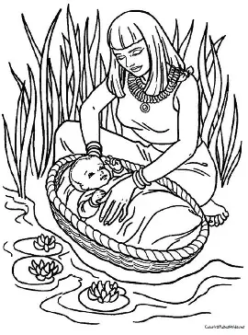

Oct. 07. 2025
Lesson #2: Moses Kills Someone
Bible Passage of the Day: Exodus 2: 11- 25
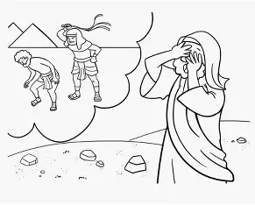

Oct. 14. 2025
Lesson #3: Moses and the Burning Bush
Bible Passage of the Day: Exodus 3
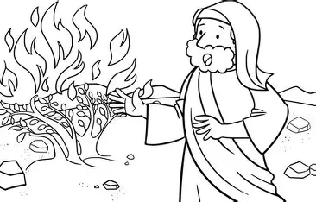

Oct. 21. 2025
Lesson #4: Moses Protesting
Bible Passage of the Day: Exodus 4
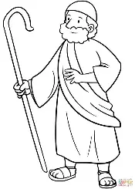

Oct. 28. 2025
Lesson #5: Moses and Aaron speak to Pharaoh (straw and bricks)
Bible Passage of the Day: Exodus 5
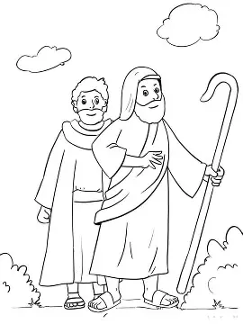

Nov. 04. 2025
Lesson #6: The Lords Promises
Bible Passage of the Day: Exodus 6: 1-13
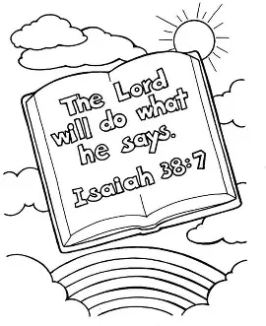

Nov. 11. 2025
Lesson #7: Aarons Staff Turns into a Serpent
Bible Passage of the day: Exodus 7: 1-13
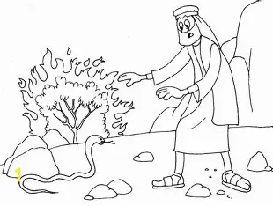

Nov. 18. 2025
Lesson #8: Plague of Blood
Bible Passage of the Day: Exodus 7: 14-25
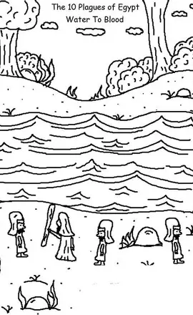

Nov. 25. 2025
Lesson #9: Plague of Frogs, Gnats, Flies
Bible Passage of the day: Exodus 8
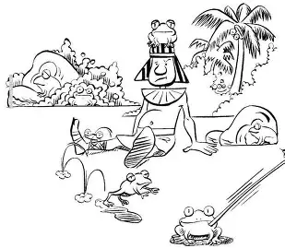

Dec. 02. 2026
Lesson #10: Plague of Livestock, Boils, Hail
Bible Passage of the Day: Exodus 9
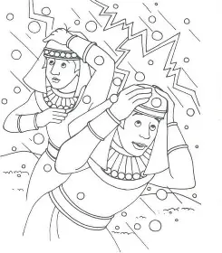

Jan. 13. 2026
Lesson #11: Plague of Locusts and Darkness
Bible Passage of the Day: Exodus 10
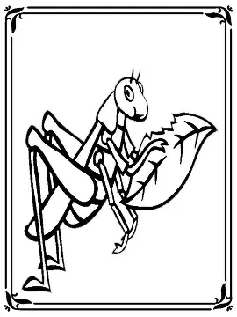

Jan. 20. 2026
Lesson #12: Death of First Born and Passover
Bible Passage of the Day: Exodus 11-12: 30
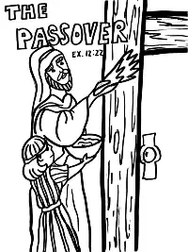

Jan. 27. 2026
Lesson #13: Israel's Exit from Egypt
Bible Passage of the Day: Exodus 12: 31-50
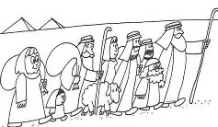

Feb. 03. 2026
Lesson #14: Isreal Departs
Bible Passage of the Day: Exodus 13:17-14
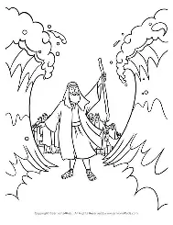

Feb. 17. 2026
Lesson #15: Song of Deliverance
Bible Passage of the Day: Exodus 15


Feb. 24. 2026
Lesson #16: Water From Rock and Quail and Manna
Bible Passage of the Day: Exodus 16-17: 7
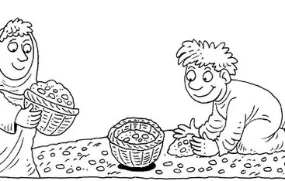

Mar. 03. 2026
Lesson #17: The Ten Commandments
Bible Passage of the Day: Exodus 20 1-17
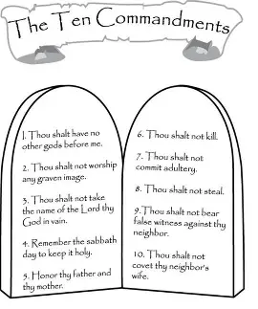

Mar. 10. 2025
Lesson #18: Talk About the Tabernacle
Bible Passage of the Day: Exodus 40
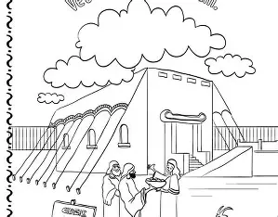

Mar. 17. 2026
Lesson #19: Moses Died, Joshua Took Over
Bible Passage of the Day: Duet. 31: 13-39
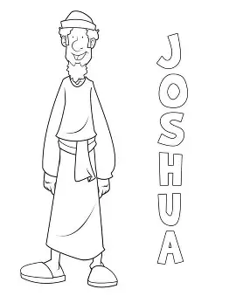

April 14. 2026
Lesson #20: Joshua Takes Over
Bible Passage of the Day: Joshua 1
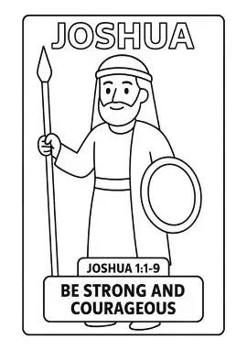

April 21. 2026
Lesson #21: Rahab Protects Spies
Bible Passage of the Day: Joshua 2
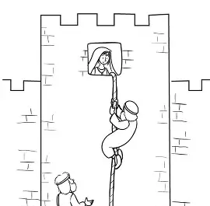

April 28. 2026
Lesson #22: Making it to the Promise Land
Bible Passage for the Day: Joshua 3

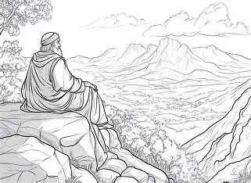

Dec. 09. 2025
Christmas
Bible Passage of the Day: Look to Luke 2
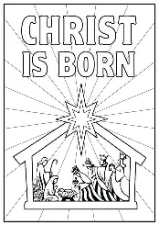

Feb. 10. 2026
Valentines Day
Bible Passage of the Day: John 3:16
GOD IS LOVE.


Mar. 24. 2026
Easter: Part One
Bible Passage of the Day: John 3:16
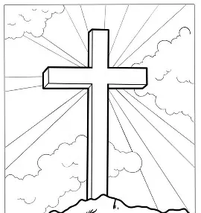

Mar. 31. 2026
Easter: Part Two
Bible Passage of the Day: John 3:16


