Sept. 23. 2025
Welcome Day:
Exodus 14:14
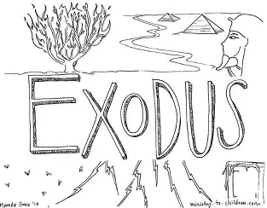

What does EXODUS mean?

What is something you look forward to in the program this year?

Sept. 30. 2025
Lesson #1: Moses Is Born
Bible Passage of the Day: Exodus 1:11- 2: 10\
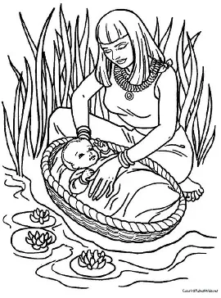
What did you learn about at Cornerstone Kids this week?

How does it feel to know God is our “protector”?

How can we turn to God when we need protection in our lives?

Oct. 07. 2025
Lesson #2: Moses Kills Someone
Bible Passage of the Day: Exodus 2: 11- 25
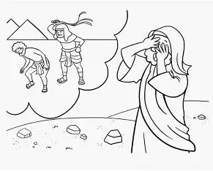
What did you learn about at Cornerstone Kids this week?

How does God help us through frustrating times?

Oct. 14. 2025
Lesson #3: Moses and the Burning Bush
Bible Passage of the Day: Exodus 3
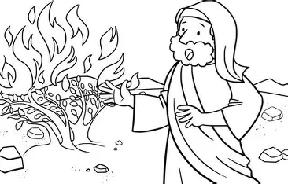
What did you learn about at Cornerstone Kids this week?

How does God talk to us in our day to day lives?

Oct. 21. 2025
Lesson #4: Moses Protesting
Bible Passage of the Day: Exodus 4
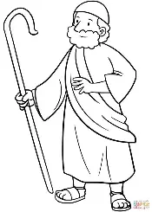
What did you learn about at Cornerstone Kids this week?

What does it mean to give your heart to God?

Oct. 28. 2025
Lesson #5: Moses and Aaron speak to Pharaoh (straw and bricks)
Bible Passage of the Day: Exodus 5
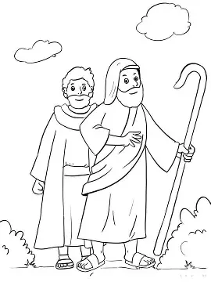
What did you learn about at Cornerstone Kids this week?

What does it mean to have a gift from God?

Nov. 04. 2025
Lesson #6: The Lords Promises
Bible Passage of the Day: Exodus 6: 1-13
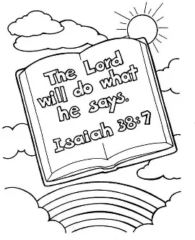
What did you learn about at Cornerstone Kids this week?

What does the phrase “God keeps His promises” mean to you?

Nov. 11. 2025
Lesson #7: Aarons Staff Turns into a Serpent
Bible Passage of the day: Exodus 7: 1-13
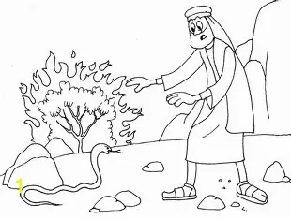
What did you learn about at Cornerstone Kids this week?

How does God make the impossible, possible?

Nov. 18. 2025
Lesson #8: Plague of Blood
Bible Passage of the Day: Exodus 7: 14-25
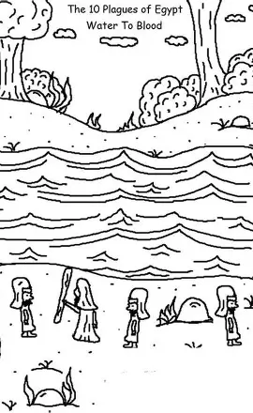
What did you learn about at Cornerstone Kids this week?

Why is the plague of blood significant?

Nov. 25. 2025
Lesson #9: Plague of Frogs, Gnats, Flies
Bible Passage of the day: Exodus 8
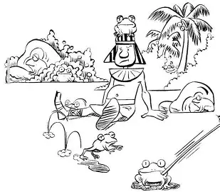
What did you learn about at Cornerstone Kids this week?

Why is this important to learn about?

Dec. 02. 2026
Lesson #10: Plague of Livestock, Boils, Hail
Bible Passage of the Day: Exodus 9
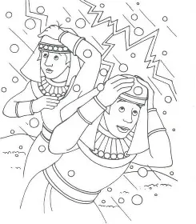
What did you learn about at Cornerstone Kids this week?

Why is this important to learn about?

Jan. 13. 2026
Lesson #11: Plague of Locusts and Darkness
Bible Passage of the Day: Exodus 10
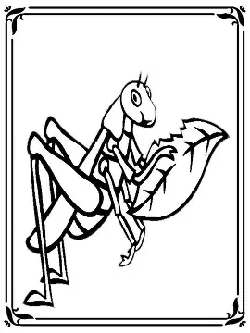
What did you learn about at Cornerstone Kids this week?

What would you do if you were in an Egyptians shoes while this was happening?

Jan. 20. 2026
Lesson #12: Death of First Born and Passover
Bible Passage of the Day: Exodus 11-12: 30
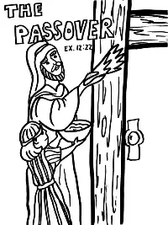
What did you learn about at Cornerstone Kids this week?

What does Passover mean? Why is the Passover important?

Jan. 27. 2026
Lesson #13: Israel's Exit from Egypt
Bible Passage of the Day: Exodus 12: 31-50
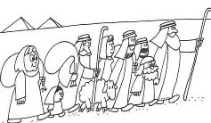
What did you learn about at Cornerstone Kids this week?

Why did the Pharoh finally let God’s people go?

Feb. 03. 2026
Lesson #14: Isreal Departs
Bible Passage of the Day: Exodus 13:17-14
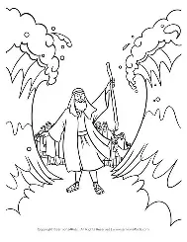
What did you learn about at Cornerstone Kids this week?

How does God deliver us now adays? (Think back to our lesson about Jesus)

Feb. 17. 2026
Lesson #15: Song of Deliverance
Bible Passage of the Day: Exodus 15
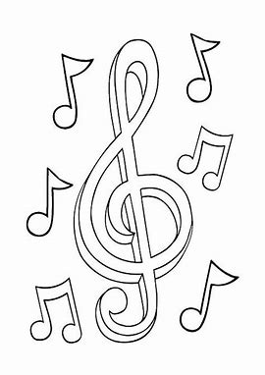
What did you learn about at Cornerstone Kids this week?

How can YOU praise God in day-to-day life?

Feb. 24. 2026
Lesson #16: Water From Rock and Quail and Manna
Bible Passage of the Day: Exodus 16-17: 7
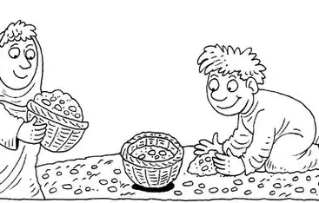
What did you learn about in Cornerstone Kids today?

How does God provide for us?

Mar. 03. 2026
Lesson #17: The Ten Commandments
Bible Passage of the Day: Exodus 20 1-17
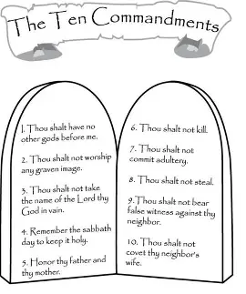
What did you learn about at Cornerstone Kids today?

Which commandment is the hardest for you to follow? Why?

Mar. 10. 2025
Lesson #18: Talk About the Tabernacle
Bible Passage of the Day: Exodus 40
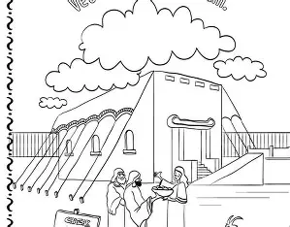
What did you learn about at Cornerstone Kids this week?

What is a tabernacle?

Mar. 17. 2026
Lesson #19: Moses Died, Joshua Took Over
Bible Passage of the Day: Duet. 31: 13-39
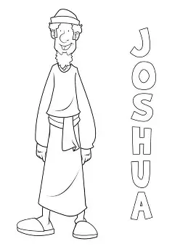
What did you learn about at Cornerstone Kids this week?

How can we be good leaders? How can we be good leaders within the Church?

April 14. 2026
Lesson #20: Joshua Takes Over
Bible Passage of the Day: Joshua 1
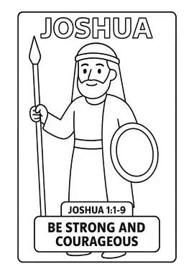
What did you learn about at Cornerstone Kids this week?

Who is Joshua?

April 21. 2026
Lesson #21: Rahab Protects Spies
Bible Passage of the Day: Joshua 2
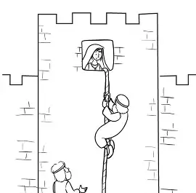

What did you learn about at Cornerstone Kids this week?

How can we relate to Rahab?

April 28. 2026
Lesson #22: Making it to the Promise Land
Bible Passage for the Day: Joshua 3

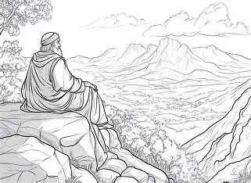
What did you learn about at Cornerstone Kids this week?

What is the promised land? How does knowing about the promised land affect you personally?

Dec. 09. 2025
Christmas
Bible Passage of the Day: Look to Luke 2
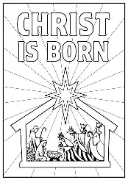
Why is the birth of Jesus significant? How does this affect YOU?

Feb. 10. 2026
Valentines Day
Bible Passage of the Day: John 3:16
GOD IS LOVE.
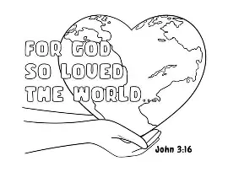
What does it mean to be loved by God?

Do you feel loved by God? Explain!

Mar. 24. 2026
Easter: Part One
Bible Passage of the Day: John 3:16
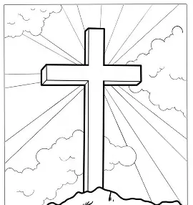
Why is it important that we know the Easter Story?

Mar. 31. 2026
Easter: Part Two
Bible Passage of the Day: John 3:16
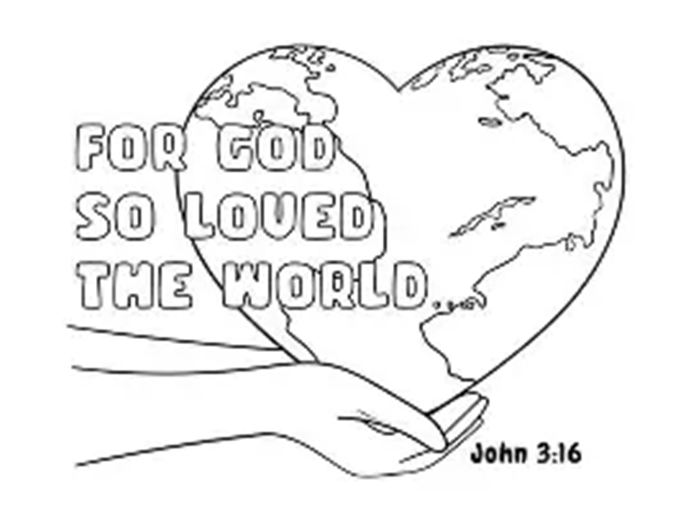
In your OWN words, explain what Jesus did:

