Cornerstone Kids Worksheets
Entwistle Community Church
March 04- June 02. 2025 Curriculum
Youth/ Children’s Coordinator: Cadence Harper

Creation 101: God Created All… INCLUDING YOU.
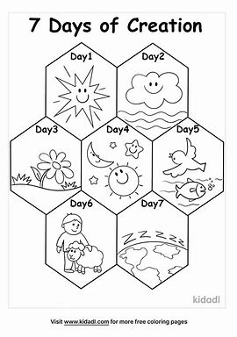

Adam and Eve: God Places us Right Where We Are Supposed to Be
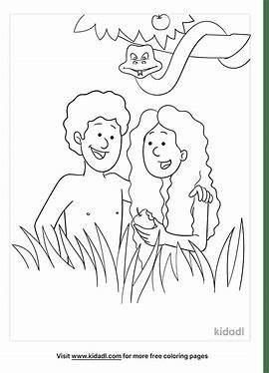

Temptation/ Free Will: Choosing Your Own Direction/ Choosing THE Direction
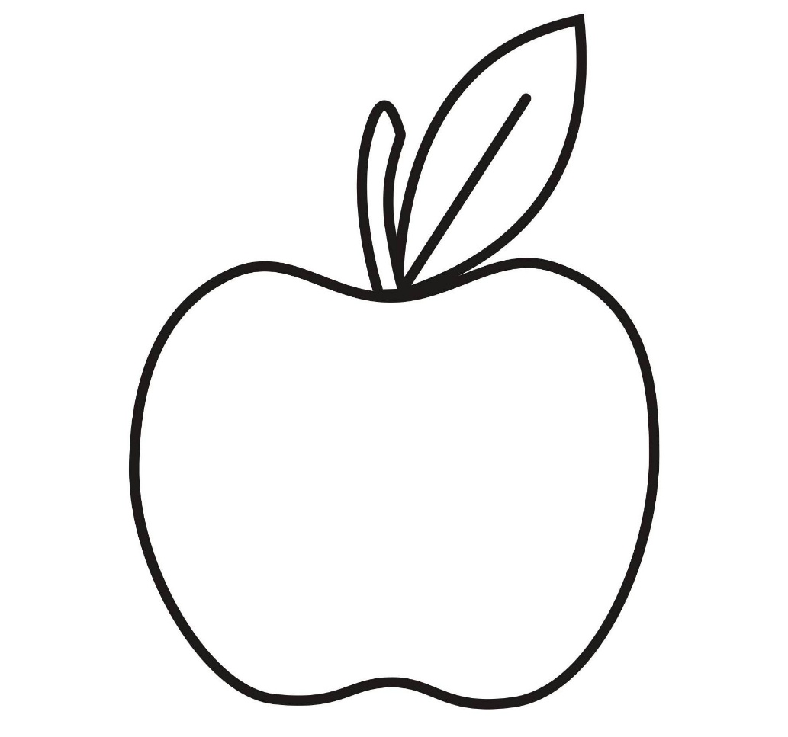

Cain Kills Abel: Which Kind of Faith Do You Have?

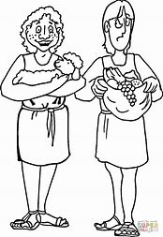

Lamech is Wrapped Up In Himself: Get Wrapped Up In Jesus Instead
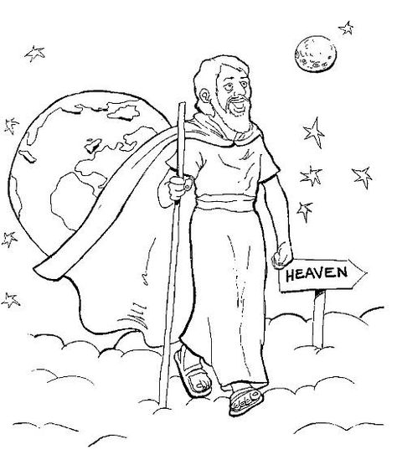

Easter Story: Why Jesus Came

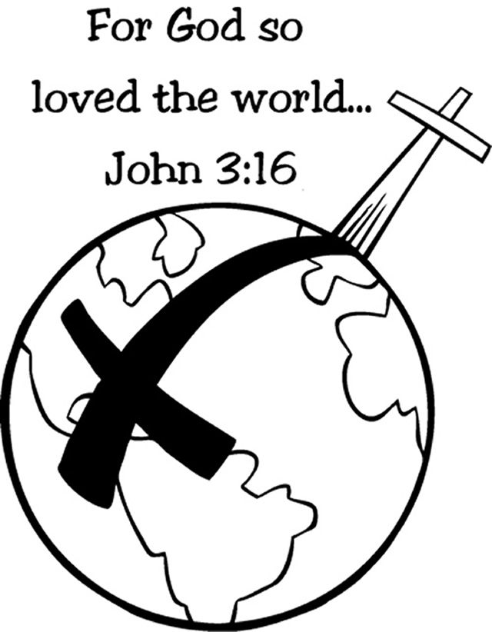

Easter Story Continued: We Are Free

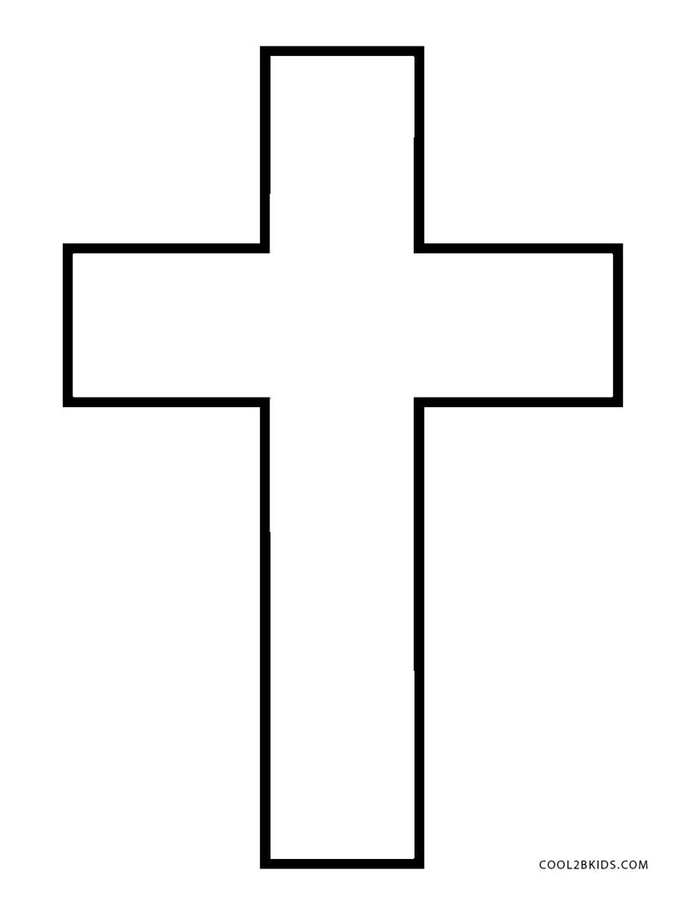

Enoch Walks with God: Our Relationship With Christ is Our Choice

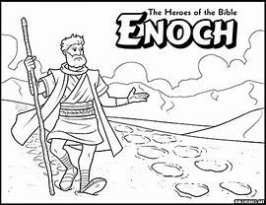

Noah Builds A Boat: What Does God Want you To Build?

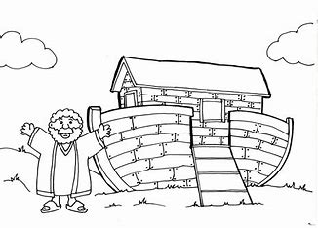

Getting Into the Boat: What is God’s Ministry for You?

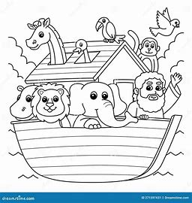

Noah Waits: God Wants Us To Trust Him In The Waiting

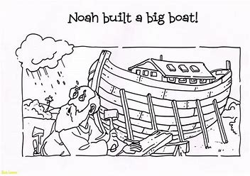

The Rainbow Promise: A Reminder of God’s Faithfulness to Us.

